AGENDA
Education, Arts & Culture Committee
http://marvista.org/committees/edcultarts
Monday, June 29th 2015, 6:30pm
Mar Vista Library (SW corner of Venice/Inglewood Blvd. intersection)
Community Room
1. Introductions - WELCOME!
2. Approval of 5/27/15 minutes and 4/30/15 minutes (attached, and at http://marvista.org/committees/edcultarts)
3. Public Comment
4. Past business updates:
MVCC NPGs
5. Discussion of next year's EACC goals
Process for identifying school representatives for 2015-16
Establish NPG review schedule, purview; discussion of lessons-learned
Newsletter, expanded website – volunteers?
Recognition of last year's commendable students – MV Fall Festival; MVCC BOD meeting; certificates?
Breadth of political vs a-political mandate
Expansion of "arts & culture" mandate
Appointments: school reps, newsletter rep, website rep, culture liaison rep (Robin?)
6. School Community news/happenings
WMV "Woods Residents'" outcome (Christopher)
National Night Out; 8/4/15, VHS (flier attached)
Middle School Forum – VNC ?
7. Public Comment
8. Future Agenda items
9. Adjourn (*by 7:55pm!*)
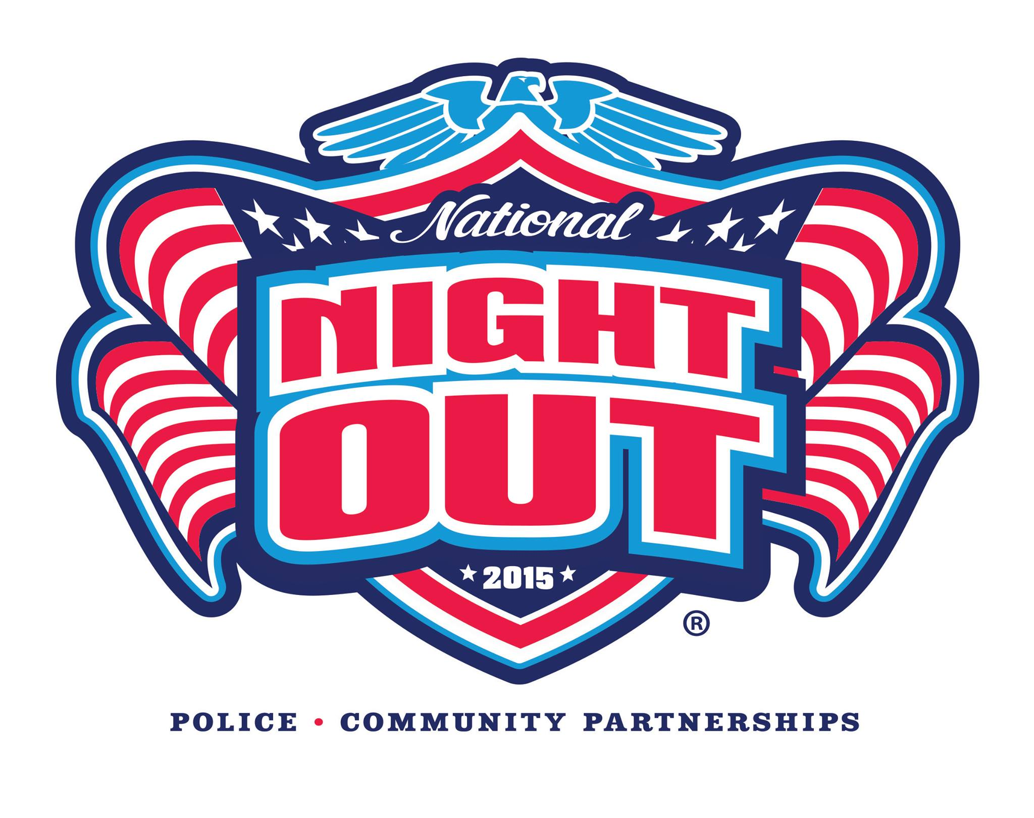
Tuesday August, 4, 2015
6:00pm – 9:00pm
@ Venice High School
Come join us for this incredible celebration of community at our local public high school with civic leaders, city resources, engaged neighbors and community organizations working to make our neighborhoods as safe, supportive and caring as possible.

- Meet our brand new Venice High School Principal and learn about all the incredible things our HS is doing to enrich/educate our youth.
- Network with Capt. Nicole Alberca, commanding officer of Pacific LAPD and your local LAPD senior lead officers (SLO)
- Want to get involved in improving your community? Meet your local neighborhood councils and associations that want your help and need your feedback.
- Add some Venice HS Spirit wear to your wardrobe options. Nothing says I’m a local than some Go Gondoliers – Rowing not drifting apparel.
- Learn about how you can create a neighborhood watch program on your block or apt building.
- Ready for the Zombie Apocalypse? No really if you’re ready for Zombie’s you’ll be ready for all the other stuff that can happen in LA…

